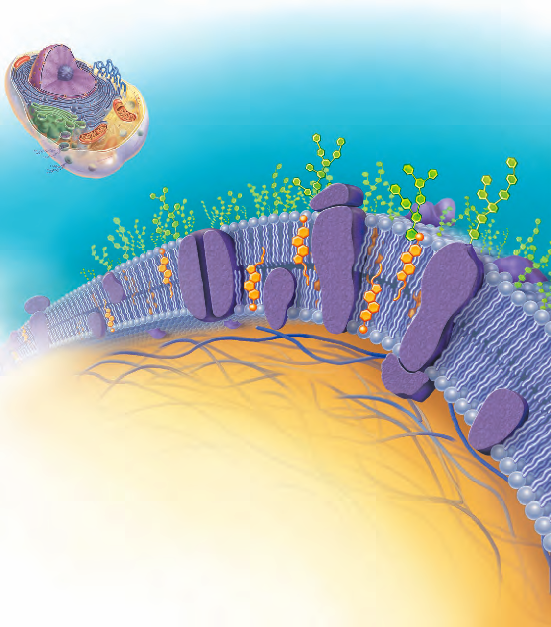Cell Membrane, pg. 65 FIG 3.3
MAJOR COMPONENTS OF THE CELL MEMBRANE:
- PHOSPHOLIPIDS
- GLYCOLIPIDS
- CHOLESTEROL
- PROTEINS
- GLYCOPROTEINS
- Sugar Molecule aka Glycocalyx

Diffusion is either ACTIVE or PASSIVE of nutrients in the interstitial fluid. The two main factors are:
1. the concentration gradient
2. the size of the particle

When does diffusion end?
Diffusion eventually produces a uniform mixture of molecules; the system reaches equilibrium, with molecules moving equally all directions (no net movement).

What affects the rate of diffusion?
molecular size (the smaller, the faster) and by temperature (the warmer, the faster)

Homeostatic Imbalance: cancer develops on glycocalyx (sugar molecule) or burned victims are open to EVERYTHING to invade the cell

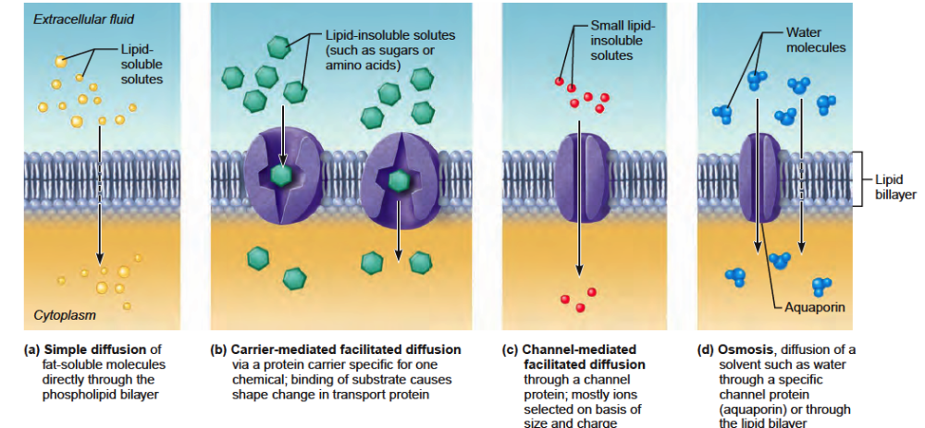
PASSIVE TRANSPORT 2 types FACILITATED OSMOSIS
DIFFUSION

Diffusion with NO ENERGY – page 69
TERM  HI → low concentration gradient | PARTICLE | METHOD OF PASSAGEWAY
Simple Diffusion/Passive Trans. | O2, CO2 | Lipid bilayer
Facilitated Diffusion | Glucose, amino acid, ion | Protein
Osmosis | Water | Lipid bilayer, AQP (aquaporins)
m

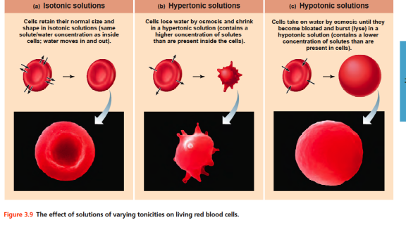

Solution: | Cell:
Hypotonic | hypertonic- bursting
Isotonic | isotonic
Hypertonic | hypotonic- shrinking

TONICITY: the ability of a solution to change the shape or tone of cells by changing their internal water volume.

Active Transport: Energy REQUIRED 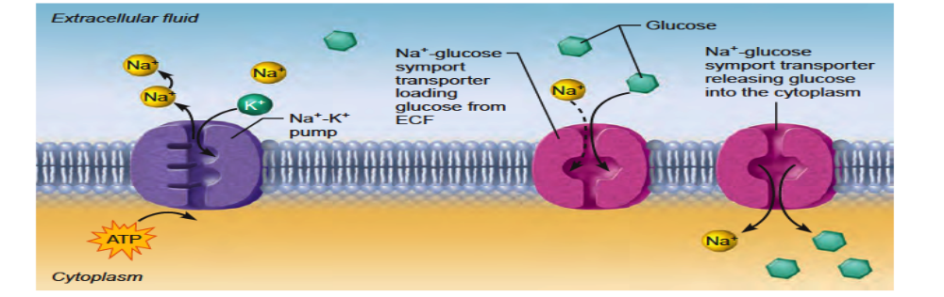
Term- low → HI concentration gradient | Particle | Method of passage
Primary active transport: energy is used directly | Calcium- hydrogen pump  Sodium-potassium pump (Na+ - K+) | 10x>K+ inside cell vs 10x> Na+outside the cell
Secondary active tansport: energy is used indirectly | Amino acid, sugar in small intestine

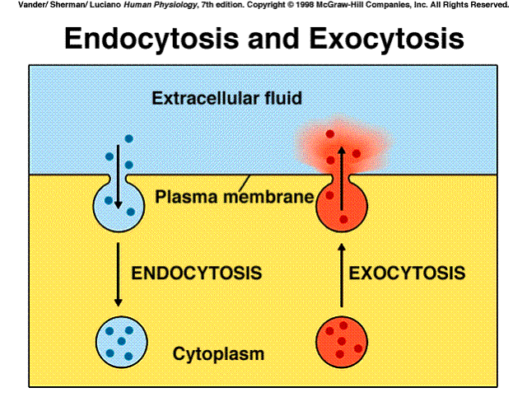
Vescular transport | Endocytosis: phagocytosis vs pinocytosis  Exocytosis | Phagocytes are white blood cells

