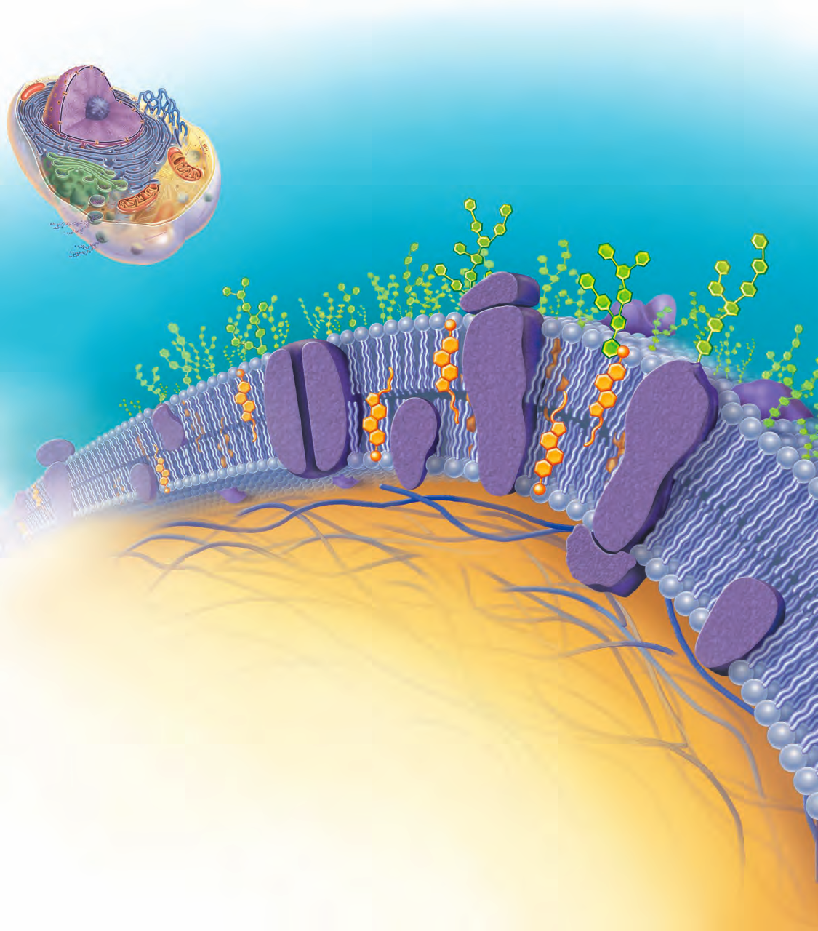Cell Membrane, pg. 65 FIG 3.3
MAJOR COMPONENTS OF THE CELL MEMBRANE:
A.
B.
C.
D.
E.
F.

Diffusion is either ACTIVE or PASSIVE of nutrients in the interstitial fluid. The two main factors are:

1.

2.

When does diffusion end?

What affects the rate of diffusion?
a.
b.

Homeostatic Imbalance: cancer develops on glycocalyx (sugar molecule) or burned victims are open to EVERYTHING to invade the cell

Page 67, fig. 3.5
Cell Junctions:

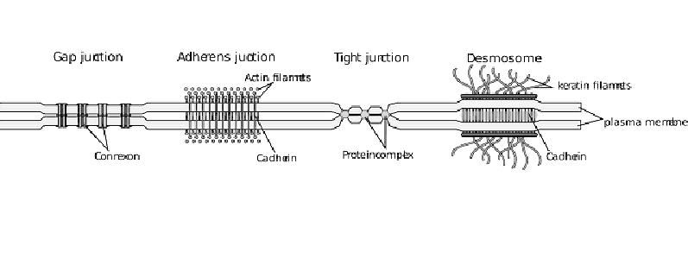

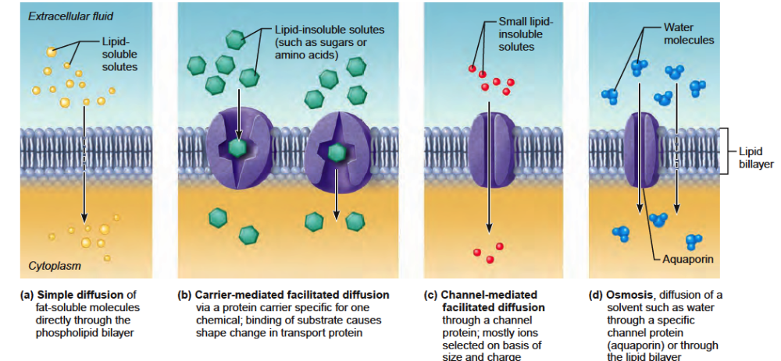

Diffusion with NO ENERGY – page 69

TERM  HI → low concentration gradient | PARTICLE | METHOD OF PASSAGEWAY

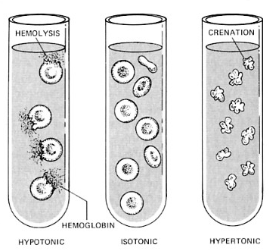

Solution: | Cell:

TONICITY:

Active Transport: ______________________________________
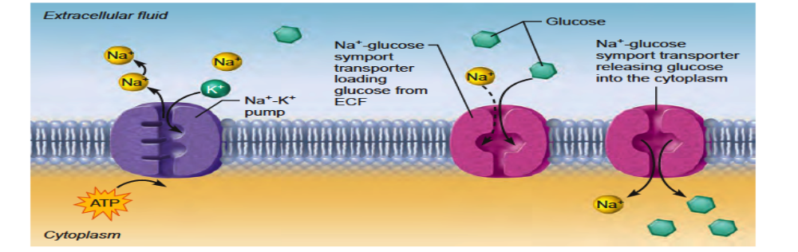
Term | Particle | Method of passage
Primary active transport:

Secondary active tansport:

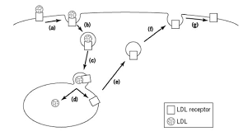

Mitochondria- pg. 83, fig. 3.17

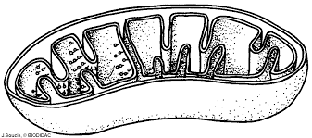

Page 95- The Cell Cycle
Cell Division occurs for body growth and tissue repair; Interphase is the time where DNA is forming for mitosis, then cytokineses where a cleavage furrow develops.

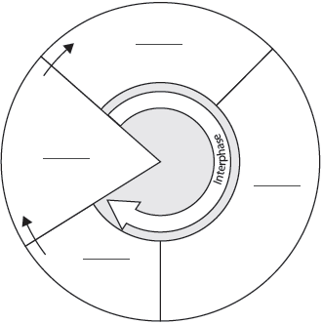
CELL LIFE CYCLE page 96 : series of changes a cell goes through from FORMING to being REPRODUCED.

2 Major Periods in a Cell Cycle

