Heart Labeling
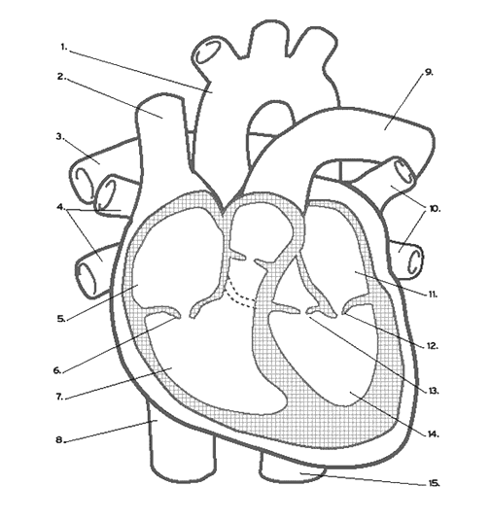
Directions: make 1 column of numbers 1-15 and complete with terms to illustrate HEART DIAGRAM TEST study guide. Answer questions 16-18

16. Use arrows to trace the blood flow in the human heart.
17. Name the major vessels that leave the heart and identify where they lead to:

18. Why is the human heart called a "double loop"?

