The Birth of Modern Science Anita Ravi, Big History Project, adapted by Newsela staff

Starting in the 1300s, the world was connected in new ways. New global networks of trade were created. These networks led to new scientific ideas. Different thinkers developed ideas and theories about how the Universe worked. They used mathematics to support their ideas. During the 1500s and 1600s, Europe became the center of knowledge and trade. Historian David Christian says Europeans achieved this because they controlled large fleets of ships that connected the world. Trade brought more than new products and profits. Christian argues that with new ideas, crops, religions and products, came new ways of thinking. People began to question traditions. One big question arose: “How can you tell what is true and what is false in the world?” The invention of printing helped books and information spread more easily in Europe than elsewhere.
The Europeans did not invent science, but they did move it forward. At the end of the 1500s, the Europeans were able to collect a great deal of knowledge. They studied it in new ways and distributed it across the continent, leading to the birth of modern science and the Scientific Revolution. Those with more information and knowledge usually have more power and wealth. The Scientific Revolution in Europe is a good example of this. Societies in Europe were able to collect and create new knowledge. This allowed them to become richer and more powerful than other societies.

New ideas, new ways of thinking
From the Middle Ages to the Scientific Revolution, European thinkers developed a new way of looking at the world. They took information from many different sources. They used this information to investigate questions they had about life, the universe, and everything. The Europeans studied ancient Greek and Muslim texts. These sources contained many different ideas about how the world worked. Many of these ideas did not agree with the Bible and Christian teachings at the time. People who offered new ideas sometimes got into trouble with religious authorities and governments. Galileo was one of those people. During his time, it was believed that the Earth was the center of the Universe. Galileo thought that the Sun was actually at the center. His belief got him sent to prison, and then put under house arrest for life. What exactly were these scientists doing and saying that angered their Church and government so much?

The scientific method explained
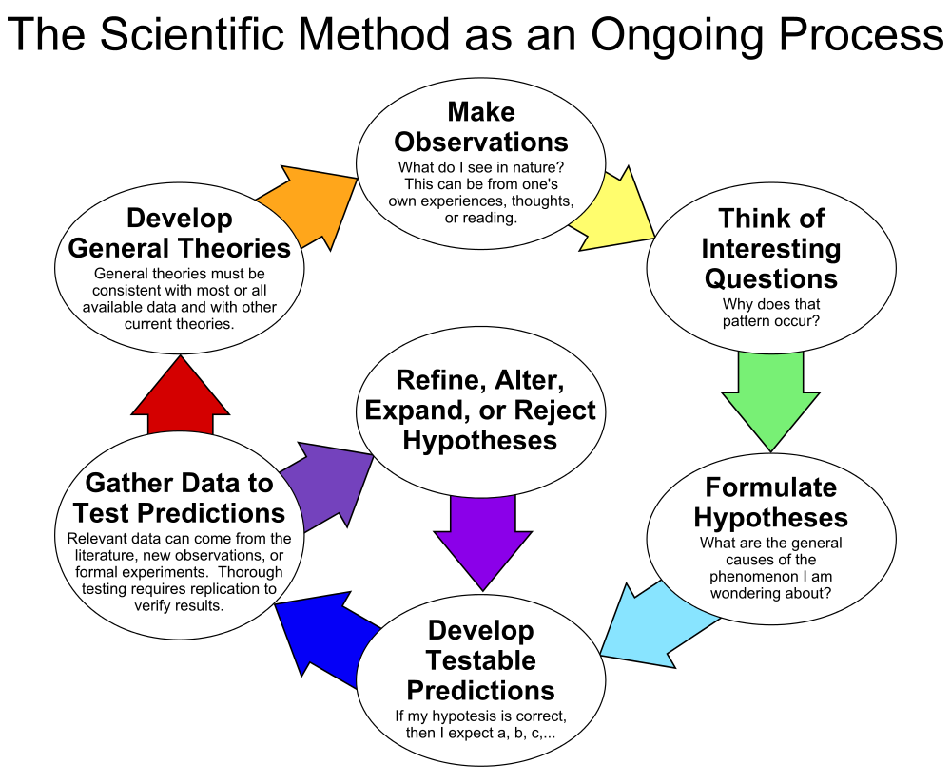
Galileo and others were using what we now call the scientific method. Here are its four steps.
Step 1: Ask a question about something you have seen. Read and discuss many different theories about it.
Step 2: Using what you have learned, make your own theory.
Step 3: Do experiments. Observe more. Keep track of the new information.
Step 4: Draw conclusions based on the evidence you have collected.
At the time, this way of solving problems was very controversial. It meant anyone could look at the world and make their own conclusions. Before this, the Bible was seen as the source of all human knowledge. How did this new way of thinking look in 1500s Europe? Let’s look at the words of a great scientist Copernicus. We'll examine his 1543 book, On the Revolutions of Heavenly Orbs. Look for the four steps we discussed above. Copernicus wanted to explain the movements of the planets. He first wrote that philosophers had no answer for "the movements in that universe which the best and most perfect Architect had made for us." He then decided to read the writings of all the philosophers on the subject. Copernicus discovered that Nicetas, who wrote about religious topics, had thought the Earth moves. Copernicus also read Plutarch, a Greek historian who wrote that "some others also had been of this opinion.” Copernicus then began using math to try to explain the rotation of the planets.

Step by step
It’s interesting that he mentions God, the “most perfect Architect,” as the one who “made” the Universe. He’s not really considering how the Universe was created. He just wants to know how it works, and how the planets and stars move in relation to one another. He then explains that he read through all the philosophers he could find who wrote about the pattern of how planets move. This is steps 1 and 2 from above. Copernicus then tried to form his own theory. He did a "careful investigation extending through years." He started with an assumption. He assumed that movements of the other planets were related to the motion of the Earth. If that were true, the movements of the planets could be explained with logic. When Copernicus finished his observations, he concluded that the Universe is a logical system. Copernicus ended this section by arguing that the universe is a sphere. He said the sphere is the most perfect shape, and the most natural. It took Copernicus years of research to prove that the Solar System is a sphere. This is step 4, above. It’s also the heart of the scientific revolution: using multiple sources of evidence to investigate life, the universe, and everything. Today, we think of the scientific method as obvious. It is a logical way to look at the world, but it was only developed about 500 years ago.

Dead snakes and flies
Let's see another example of this way of thinking. We will look at Francisco Redi’s work on insects from his 1668 book, The Generation of Insects. At the time most people believed worms just grew out of anything that was dying or decaying. He set out to see if that was true. Let’s look for his pattern of thought: How does he move through the four steps? At first, Redi ordered three snakes to be killed. He placed them in an open box to decay. Soon he saw that they were covered with worms. The worms ate all the meat. When the meat was gone the worms wanted to escape. Redi closed the box. Eventually, the worms stopped moving. They appeared to shrink and "assume a shape like an egg." After eight days, flies came out. But Redi did not stop there. He did similar experiments with the raw and cooked flesh of ox, deer, buffalo, lion, tiger, dog, goat, lamb, rabbit; and sometimes with the flesh of ducks, geese, hens, swallows. Finally, he experimented with different kinds of fish. In every case, flies appeared. He almost always saw that the decaying flesh was not just covered with worms, but with the eggs where the worms came from. After what he had seen, he began to think that the worms came from the droppings of flies, not from the decay of the meat. He became more confident in this belief when he found that flies had hovered over the meat before it grew wormy.
He decided to do more experiments. Redi put some dead animals in four large jars that he sealed. Then, he filled other jars but left them open. Before long, the meat and fish in the open jars became wormy. Flies were coming and going. Outside the closed jars, there was occasionally a maggot that was trying to get inside and feed. But inside the jars he did not see a worm. The meats inside the closed jars had rotted. Redi believed he had found enough proof. He concluded that worms did not come from the rotting meat. Instead, they were put there by flies laying eggs. He had seen that everyone around him believed rotting meat created worms. He then set out to prove or disprove this belief. He did this by watching lots of different types of dead meat decay over time and tracking what he observed.

Logic, evidence, and proof
This method of experimentation became the system of scientific proof. This was the birth of modern science. The examples we looked at above are just two examples of how these thinkers — now called scientists — tried to explain what they observed in the natural world. Copernicus, Redi, and others like them across Europe helped to establish logic, evidence, and proof as central to human thought. They helped to create a new way of thinking — using observation and experimentation — not religion — to study the world. This turned into the Age of Enlightenment.

Your Assignment (On a separate piece of paper)
Writing Prompt
Write a short paragraph that explains the central idea of the article. Use at least two details from the article to support your response. (2 pt)

Quiz
1. Based on the introduction, which of these statements about Europe in the 1500s and 1600s is TRUE? (2 pt)
- It was difficult for Europe to do much trading with other parts of the world.
- Europe became known as the place that invented science and scientific understanding.
- It was difficult for Europe to spread information across the continent because there were so many different ways of thinking.
- Europe became powerful partly because of the information and ideas it exchanged through trade.
2. Which of these selections from the section "The scientific method explained" BEST shows that the Scientific Revolution valued independent thinking? (2 pt)
- Step 2: Using what you have learned, make your own theory.
- Step 3: Do experiments. Observe more. Keep track of the new information.
- He then decided to read the writings of all the philosophers on the subject.
- Copernicus discovered that Nicetas, who wrote about religious topics, had thought the Earth moves.
3. Fill in the blank: Overall, the article is organized around... (2 pt)
- the cause of the Scientific Revolution and examples of its significant effect on scientific thinking and knowledge.
- the problems with the way science was studied before the Scientific Revolution and the possible solutions proposed by important scientists.
- a list of famous scientific discoveries in Europe discussed in the order of their importance to changing how people thought.
- a comparison between the way European religious leaders in the Middle Ages studied science and the way European scientists in the 1500s studied science.
4. What is the connection between the sections "Step by step" and "Dead snakes and flies"? (2 pt)
- Both sections present a problem and then the solution to that problem.
- Both sections describe the sequence of steps taken in a scientific study.
- The "Step by step" section discusses the cause of a particular event, and the "Dead snakes and flies" section describes the effects of that event.
- The "Step by step" section describes one method of scientific study and the "Dead snakes and flies" section describes a different method of scientific study.

