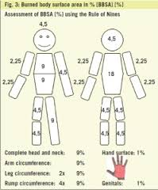

Be able to compute the body regions (see page 13 for terms) using this chart. Chart will NOT be supplied for the test.

