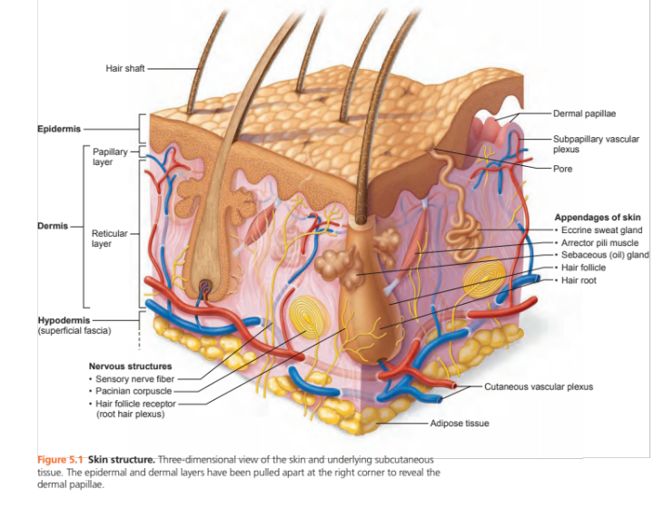

SKIN STATS and FACTS:
- Surface area of 23 square feet
- Weighs approx 10 lbs
- 7% of total body weight
- 1.5 to 4.4 mm thick
- Known as integument (means covering)
- Protects us from bacteria
- Insulates water and heat (body temperature)
- Synthesizes Vitamin D

INTEGUMENTARY SYSTEM is made up of 2 regions- the epidermis and dermis

THE STRATA OF THE EPIDERMIS

what’s your silly sentence? | STRATA- layers of epidermis external to deep has 5 layers | physiology
 | corneum | - protects the integument
 | lucidum | - known as the Clear layer; does not serve a purpose; visible in thick skin
 | granulosum | - Where keratinocytes are made; keratin is a fibrous (thread-like) protein used for its protective properties; protein that waterproofs skin
 | spinosum | - ‘Prickly’ layer- keratinocytes shaped like spiked iron balls  - contains the most melanin granules and dendritic cells
 | basale | - made up of NEW keratinocytes that goes under continuous mitosis giving it the name of stratum germinativum  - Melanocytes create melanin that protects skin from UV radiation;  - Dendritic cells- (Langerhans cells) that ingest foreign substances and works with Immune system.  - Tactile cells (Merkel) sensory receptor for touch

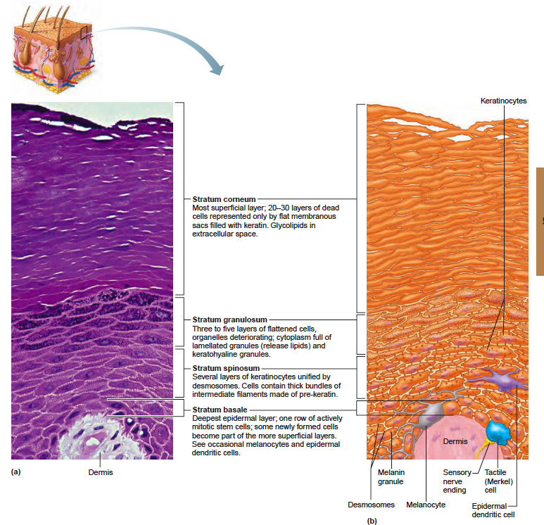
STRATUM OF THE EPIDERMIS TYPES OF CELLS IN EA. STRATA

THE DERMIS

DERMIS | ANATOMY | PHYSIOLOGY
2 layers:  1.papillary and  2. reticular layer | fibrous, connective tissue.  VASCULARIZED:rich in nerve fibers, blood vessels and lymphatic vessels the hair follicle, oil and sweat glands originate in this level | Binds the entire body together like a body stocking
Papillary Layer |  | 1. allows phagocytes and other defensive cells to watch for bacteria that invade this layer  2. touch sense  3. sweat pores leave fingerprints
Reticular Layer | 80% of the dermis is coarse, irregularly arrange, dense fibrous connective tissue.  Flexure lines | cleavage lines-  Collagen  Elastic fibers
Homeostatic Imbalance | ________ aka ‘stretch marks’ | dermal skin in pregnant women tear due to extreme stretching

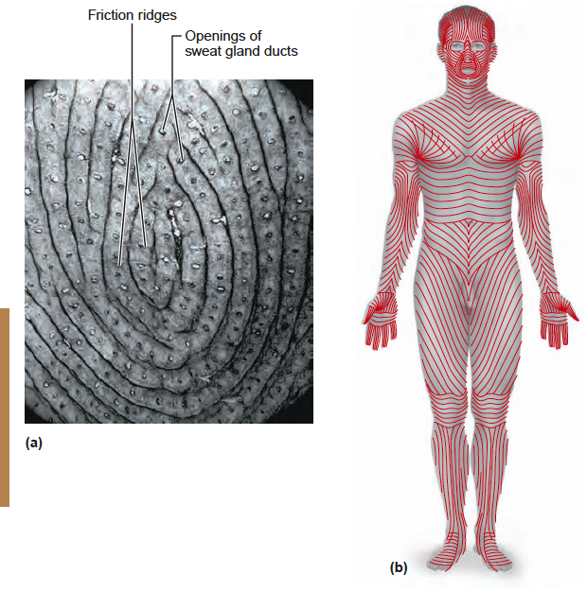PAGE 154, DERMAL MODIFICATIONS result in characteristic skin markings

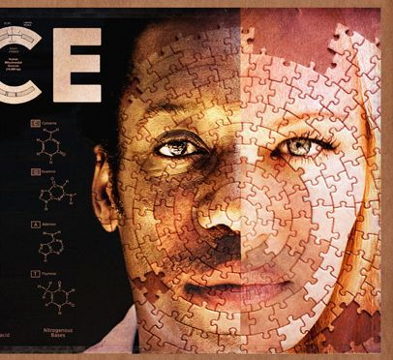

Pages 154-155
SKIN COLOR:
Skin Color | explanation of appearance | Homeostatic Imbalance
Melanin
Carotene |  | none
Hemoglobin

Pages 155-15 160 Appendages of the Skin: nails, sweat glands, sebaceous glands and hair

Sweat glands are over the entire skin surface EXCEPT nipples and external genitalia; 3 million per person! There are 2 types of sweat glands: eccrine and apocrine. Ceruminous and mammary glands are in this category
Eccrine:
Apocrine
Ceruminous
Mammary

Sebaceous glands produce sebum.
Size of glands: location of body | Physiology

Page 157: Hair and Hair Follicles
Main function is to ___________! It senses insects on skin before they bite or sting us. Eyelashes shield eyes, nose hairs filter particles; Arrector pili is a muscle to form goose bumps

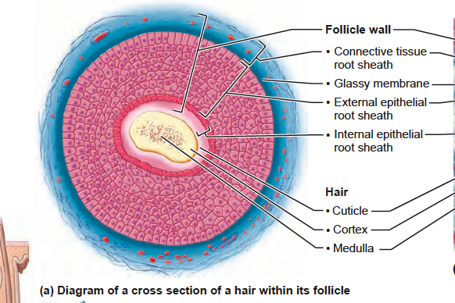
Page 158: Diagram of a cross section of a hair within its follicle

Types and Growth of Hair
Vellus
Terminal

Nails- a useful tool for: 1. 2.
Lays up against _______ (pink color)
Homeostatic Imbalance:
nail color
shape
texture

Page 162-163: Skin Cancer
Basal | slow growing, most common harmless
squamous | scalp, ears, lower lip and hands can metastisize
melanoma | resistant to chemotherapy, most harmful.

ABCDE Rule: how to determine whether the mole is cancerous
A | Assymmetry
B | Border irregularity
C | Color
D | Diameter
E | Elevation

Pages 163-164: BURNS are considered tissue damage caused by: heat, electricity, radiation, or certain chemicals.

How burns affect the body: burns kill proteins and cause cell death in the affected areas.
Life-threatening: when the loss of body fluids contain proteins and electrolytes, results in dehydration and electrolyte imbalance. Soon after, renal shutdown and circulatory shock.
Treatment: IV to replace lost fluids and supplementary nutrients through gastric tubes and IV lines because the food calories can not suffice.

RULE OF 9’s: to determine how much of the body surface is burned, this method divides the body into 11 sections, each worth 9%. The genitals=1%.

Palmar surface are can be used to estimate relatively small burns (< 15% of total surface area) or very large burns (> 85%, when unburnt skin is counted). For medium sized burns, it is inaccurate.
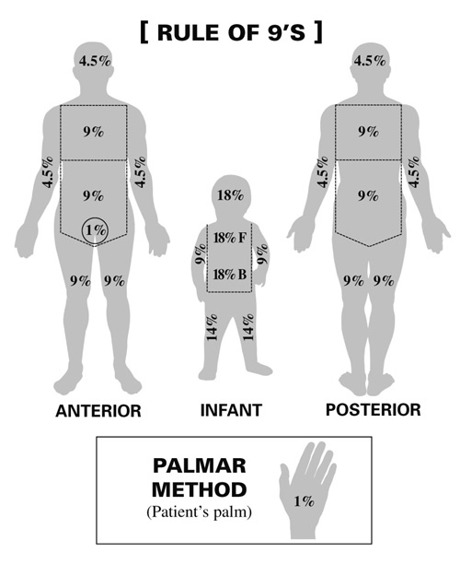

First Degree- sunburn
Partial thickness burns
Second Degree- partial thickness burns
Third degree burns- full-thickness burns

Procedures for skin grafting:

New advances in skin grafting:

Critical burns are any one of these 3 descriptions:

DEVELOPMENTAL ASPECTS OF THE INTEGUMENTARY SYSTEM p 165

In the womb:
4th month
5th - 6th months
7th month
At Birth:
Infancy/childhood
Adolescence
Adulthood
50s
Old age

5 steps to Slow down the Aging Process:

