Organization of the Nervous System
- List the general functions of the nervous system.
- Explain the structural and functional classifications of the nervous system.
- Define central nervous system and peripheral nervous system and list the major parts of each.
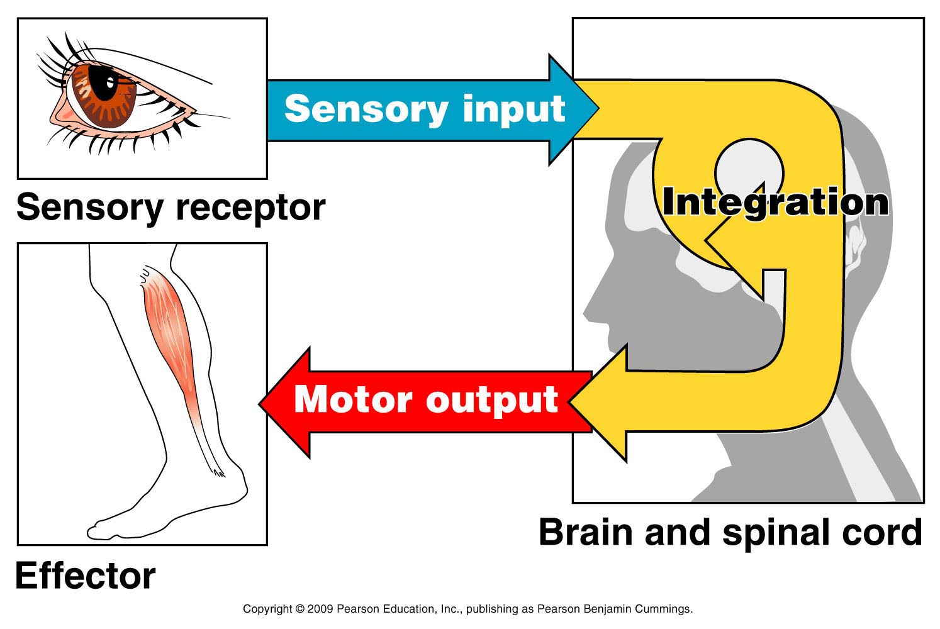

- Stimuli is intecepted; nerve fibers that carry information TO THE CNS
- Decides what action is needed
- A response to the integrated stimuli, causing a response to muscles or glands; nerve fibers that carry impulses AWAY FROM THE CNS to the PNS

CNS are the organs, brain and spinal cord working with the PNS made up of the cranial and spinal nerves
Nervous Tissue: Structure and Function
- State the function of neurons and neuroglia.

Type of Neuroglia in the CNS |  | Anatomy | Physiology
Astrocyte | 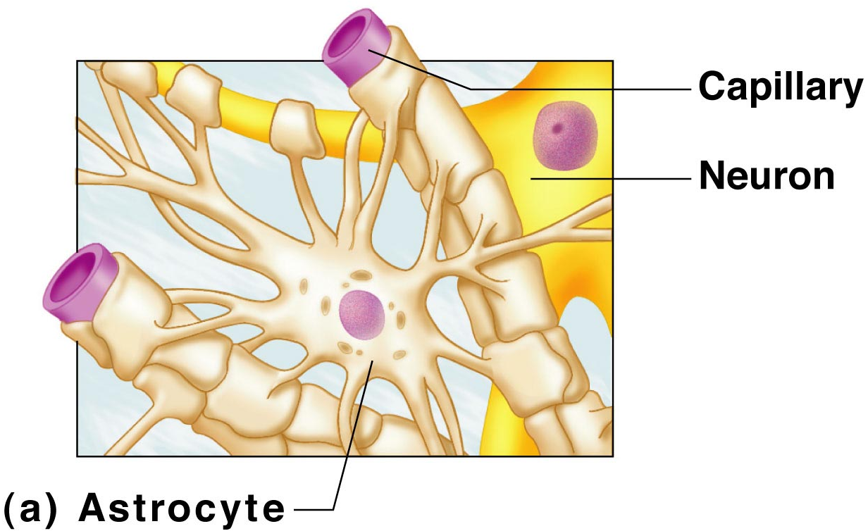 | Many Star-shaped cells | Brace neurons  Form barrier between capillary and neurons  Control the chemical env of the brain
Microglia | 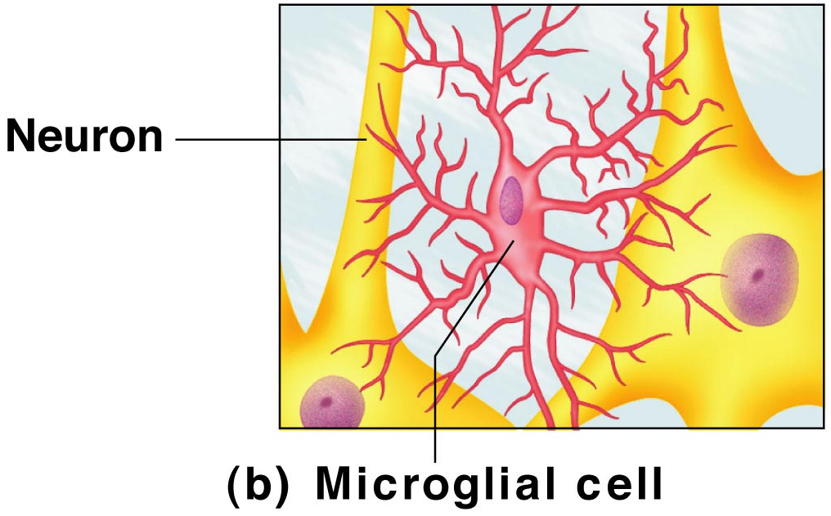 | Spiderlike phagocytes | Dispose of debris
Ependymal | 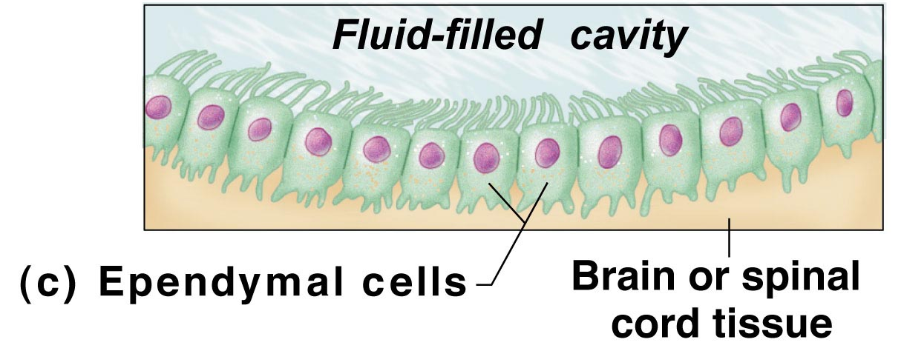 | Line cavities of the brain and spinal cord | Circulate cerebrospinal fluid
Oligodendrocytes | 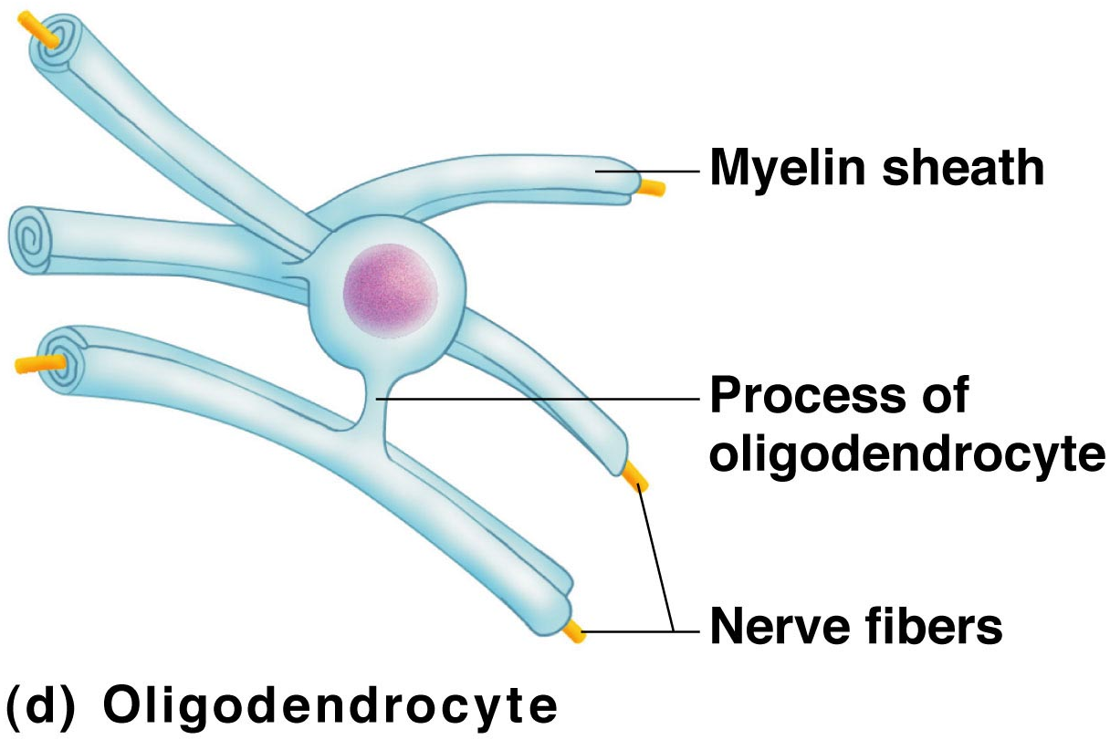 | Wrap around nerve fibers in the CNS | Produce myelin sheaths
Neuroglia found in the PNS
Satellite | 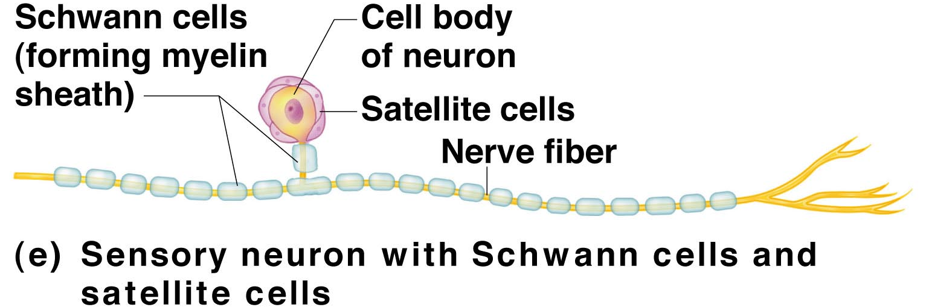 | Outlines the cell body | Protects neuron cell bodies
Schwann cell |  |  | Form myelin sheath in the PNS

- Describe the general structure of a neuron, and name its important anatomical regions.

- 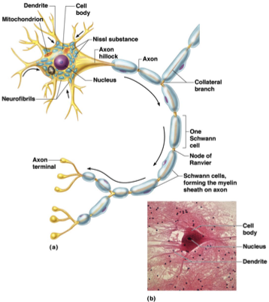
Cell body | Nucleus, Mitochondria ER Golgi Apparatus
Dendrites | Conducts impulses toward  the cell body
Axon | Conducts impulses away from the cell body
Schwann Cell | A segment of an axon covered in myelin sheath
Node of Ranvier | Space between two Schwann Cells

List the two major functional properties of neurons.

- 1. structural classification- multipolar, bipolar and unipolar neurons
2. functional class- interneurons are in the integration process, motor neurons are from CNS to a gland/muscle, and sensory neurons conduct along afferent pathway to CNS

- Classify neurons according to structure and function.pp 396

OBJECTIVE: Describe the events that lead to the generation of a nerve impulse and its conduction from one neuron to another.

Fig. 11.11, page 400

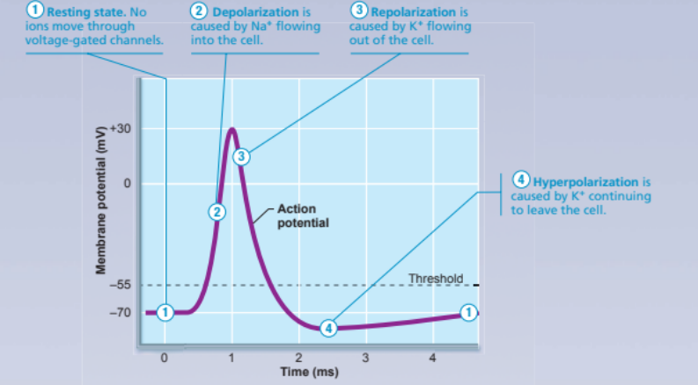

http://brainu.org/files/movies/action_potential_cartoon.swf
 | Line Graph | Sodium Na+  - Outside door  - Inside door | Potassium K+  Door
Resting Potential | -70 mV | 1. closed 2. open | closed
Depolarization | ascending | 1. open 2. Open  1. open 2. close | Closed  open
Repolarizing | descending | 1. close 2. open | close
Returns to resting levels | -70 mV | 1. closed 2. open | closed

- Sodium (Na+) ions are positively charged and are OUTSIDE of the neurons which causes them to ‘sneak’ in because of diffusion (hi to low concentration gradient)
- Meanwhile, Potassium (K+) ions are positively charged that are INSIDE of the neurons and thru diffusion, they ‘leak’ out
- Membrane potentials are created by the imbalance of having K+ leak out > Na+ sneaks in
- Resting potential means that there is NO ACTION POTENTIAL being initiated; the measurement on graph is -70mV

When a neuron is stimulated, the electrical impulse travels down the axon called the ACTION POTENTIAL.

- If a neuron is depolarizing, the value is closer to ZER0
- Repolarizing neutrons are returning to -70 mV or is in resting potential
- Na+K+ pumps balance the neuron by removing 3 Na+ and returning 2 K+ in.

- The Action Potential occurs repeatedly along the axon from the cell body to the axon terminal.
- Neurotransmitters are chemicals that are tasted by dendrites of the next neuron causing for the cycle to repeat

Chapter 12- THE CENTRAL NERVOUS SYSTEM pp. 431-450 Information is from Neuroscience for Kids
Brain Region | Page | Related Terms | Image | Physiology
Cerebral hemisphere | 433-441  435-439 | Lobes: frontal,parietal,occipital,temporal, insula  Fissure-longitudinal, transverse cerebral,  Sulci- ridges separating gyri  Gyri- spaces between sulci  Cerebral Cortex- The conscious mind; be aware of ourselves, sensations, to communicate, recall, understand, initiate voluntary movements | 434  438 | Most superficial  Makes up 83% mass  Thought, voluntary movement, language, reasoning perception  - contains 3 areas: motor, sensory and association  - hemispheres work together  - conscious behavior involves the cortex
Diencephalon | 441-445 | THALAMUS  HYPOTHALAMUS is composed of several different areas and is located at the base of the brain. The hypothalamus is only 1/300 of the total brain weight. One function of the hypothalamus is the control of body temperature. The hypothalamus detects changes in body temperature and sends commands to adjust the temperature. For example, the hypothalamus can detect fever and respond by sending a command to expand capillaries in the skin. The expansion of the capillaries cools the blood and results in a drop in body temperature. The hypothalamus also controls the pituitary.  EPITHALAMUS | 442  443  443 | The thalamus receives sensory information from other areas of the nervous system and sends this information to the cerebral cortex. The thalamus is also important for processing information related to movement.  Autonomic Nervous System  - Emotional response  - Body temp regulation  - Regulation of food intake  - Regulation of water balance/thirst  - Regulation of sleep-wake cycles  - Control of endocrine system functioning  Contains pineal gland-secretes melatonin (sleep inducement & antioxidant)
Brain Stem | 445-450 | Midbrain  Pons  Medulla Oblongata | 445  447  447 | Controls breathing  Cardio center, respiratory center and various (vomit, hiccup, swllow, cough, sneeze
Cerebellum | 450-451 | Located behind the brain stem, the cerebellum is similar to the cerebral cortex because it has hemispheres and a cortex that surrounds the hemispheres |  | Controls balance and equilibrium using the inner ear, eye and skeletal muscles;

Protection of the Brain
Meninges
- cover and protect the CNS
- protect blood vessels and enclose venous sinuses
- contain cerebrolspinal fluid
- form partitions in the skull
- Made up of superficial to interior: Dura Mater, Arachnoid, Pia Mater; all layers are fused together
Cerebrospinal Fluid
- (CSF) found in and around the brain and spinal cord
- forms liquid cushion that gives buoyancy to the CNS structures
- reduces brain weight by 97% and prevents brain from crushing under its own weight
- protects from trauma
- helps nourish the brain, carries hormones
- About one half cup of CSF are in an adult
Blood-Brain Barrier
A protective mechanism that helps maintain a stable environment for the brain.
Injury to the brain → breaks down the blood brain barrier

PNS- PERIPHERAL NERVOUS SYSTEM: consists of nerves and ganglia found outside of the CNS.
Cranial Nerves: 12 pairs in the head and neck

Brain injuries

Cerebrovascular accidents
CVA
Ischemia
TIA’s

Degenerative brain disorders
Alzheimer’s Disease
Parkinson’s Disease
Huntington’s Disease

Concussion
Contusion
Subdural hemorrhage
Cerebral edema

- Olfactory: smell
- Optic: vision
- Oculomotor: direct eyeball; eyelid; control lens and pupil
- Trochlear: external eye muscle
- Trigeminal: sensory impulses from skin of face, mucosa of nos/mouth; activate chewing
- Abducens: rolls eye
- Facial: facial expression; lacrimal&salivary glands; taste buds
- vestibucocochlear: balance/hearing
- Glossopharyngeal: swallowing/saliva production
- Vagus: promote digestive activity and help regulate heart
- Accessory: muscles that allow head to rotate and shrug shoulders
- Hypoglossal: tongue

SPINAL NERVES- 31 pairs divided into four plexuses: Cervical, brachial, lumbar, sacral

Cervical  Brachial  Lumbar  Sacral | Diaphragm; shoulder and neck  Deltoid, tricep, forearm, hand, arm, wrist  Lower abs, butt, thigh, hip, leg  Lower trunk, leg, foot

